Name ______________________________________ Ms. Abadie’s ___________ Period

Chapter 1  Pre-Algebra | Equations
MAFS.8.EE.3.7 | Solve linear equations in one variable.
Essential Question | How can I solve a linear equation with one variable?  In this lesson I am using opposite operations, so I can find the value of the variable.
1.1  Solving Simple Equations | 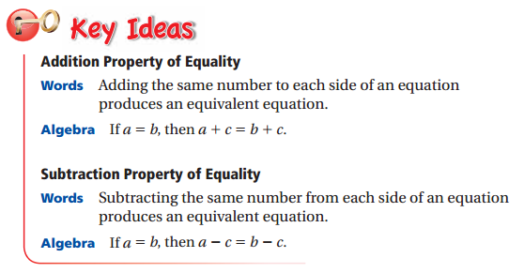
Example 1  Solving Equations using Addition or Subtraction | 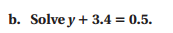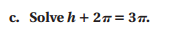
On Your Own | 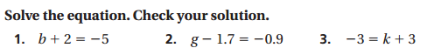
 | 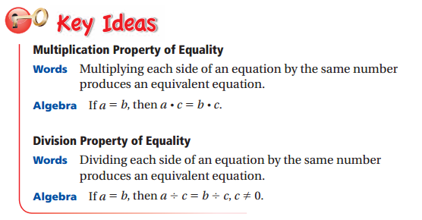
Example 2  Solving Equations using Multiplication or Division | 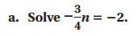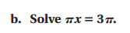
On Your Own | 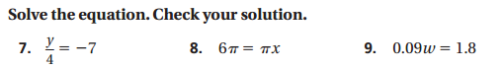
Example 3  Identifying the Solution of an Equation | 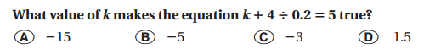
Example 4  Real Life Application | 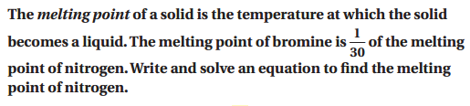  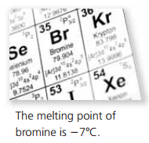
On Your Own | 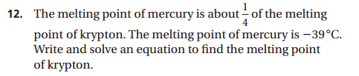

MAFS.8.EE.3.7b | Solve linear equations with rational number coefficients, including equations whose solutions require expanding expressions using the distributive property and collecting like terms.
Essential Question | How do you solve multi-step linear equations?  In this lesson I am using what I know about solving simple equations, so I can use it to solve multi-step equations.
1.2  Solving Multi-Step Equations | 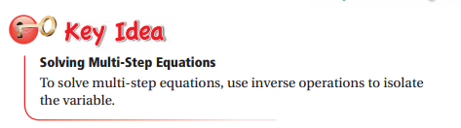
 | ***Always combine like terms or distribute first when you can!***
Example 1  Solving a Two-Step Equation | 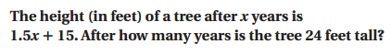
Example 2  Combining Like Terms to Solve an Equation | 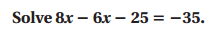
On Your Own | 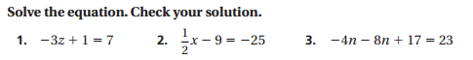
Example 3  Using the Distributive Property to Solve an Equation | 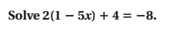
Example 4  Real Life Application | 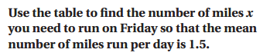  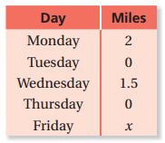
On Your Own | 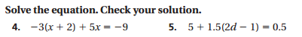  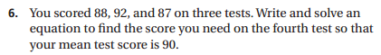

MAFS.8.EE.3.7a | Give examples of linear equations in one variable with one solution, infinitely many solutions, or no solutions.
Essential Question | How do you solve an equation with variables on both sides?  In this lesson I am using opposite operations, so I can combine the variables on one side and combine the numbers on the other side of the equal sign.
1.3  Solving Equations with Variables on Both Sides | 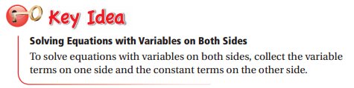
Example 1  Solving Equations with Variables on Both Sides | 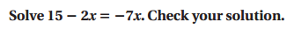
Example 2  Using the Distributive Property to Solve an Equation | 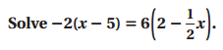
On Your Own | 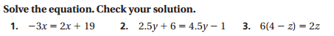
Example 3  Solving Equations with No Solution | 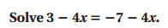
Example 4  Solving Equations with Infinitely Many Solutions | 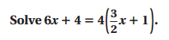
On Your Own | 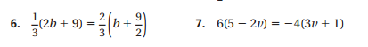
Example 5  Writing and Solving an Equation | 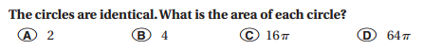  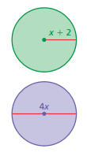
Example 6  Real Life Application | 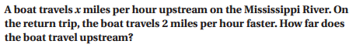  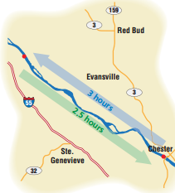
On Your Own | 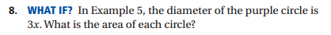  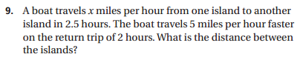

Essential Question | How do you solve an equation for a different variable?  In this lesson I am using what I know about solving equations, so I can use it to solve for other variables.
1.4  Rewriting Equations and Formulas | 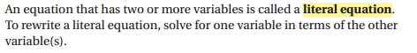
Example 1  Rewriting an Equation | 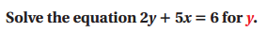
 | 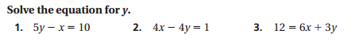
Example 2  Rewriting a Formula | 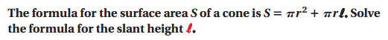  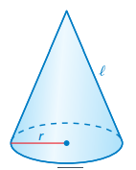
On Your Own | Solve the equation for b.  Solve the equation for P.  Solve the equation for h.
 | 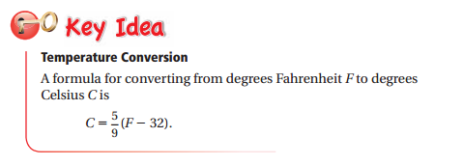
Example 3 | Solve the temperature equation for F.
Example 4  Real Life Application | 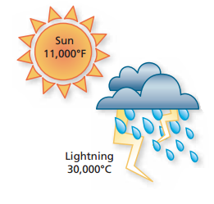
On Your Own | 