Name ______________________________________ Ms. Abadie’s ___________ Period

Chapter 4  Pre-Algebra | Graphing and Writing Linear Equations
MAFS.8.EE.2 | Cluster 2: Understand the connections between proportional relationships, lines, and linear equations.  MAFS.8.EE.2.5 Graph proportional relationships, interpreting the unit rate as the slope of the graph. Compare two different proportional relationships represented in different ways. For example, compare a distance-time graph to a distance-time equation to determine which of two moving objects has greater speed.  MAFS.8.EE.2.6 Use similar triangles to explain why the slope m is the same between any two distinct points on a non-vertical line in the coordinate plane; derive the equation y = mx for a line through the origin and the equation y = mx + b for a line intercepting the vertical axis at b.
Essential Question | How can you recognize a linear equation? How can you draw its graph?  In this lesson I am learning how to graph linear equations, so I can find the solutions of the equation.
4.1  Graphing Linear Equations | 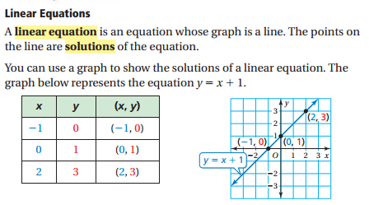  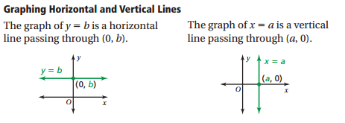
Example 1  Graphing a Linear Equation | 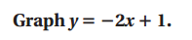
Example 2
Graphing a Horizontal or Vertical Line
On Your Own | 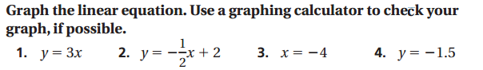
Example 3  Real Life Application | 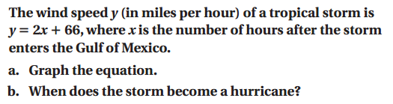  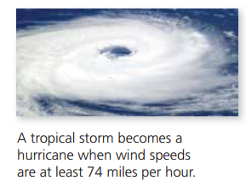
On Your Own | 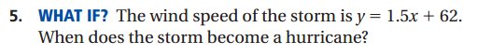
Essential Question | How can you use the slope of a line to describe the line?  In this lesson I am learning how to find the ratio of the change in y to the change in x, so I can find the slope of a line.
4.2  Slope of a Line | 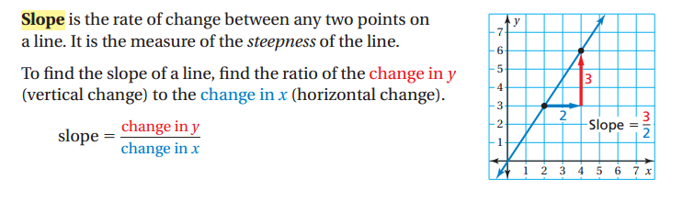  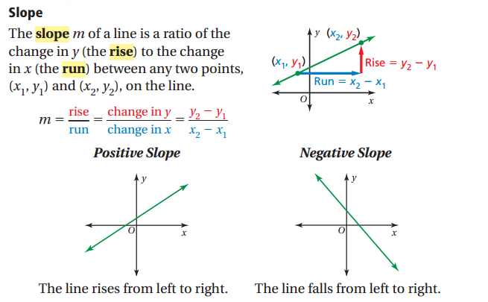
Example 1  Finding the Slope of a Line | 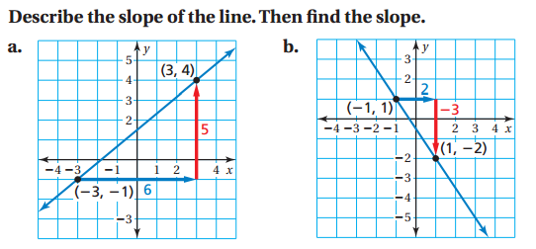
Example 2  Finding the Slope of a Horizontal Line | 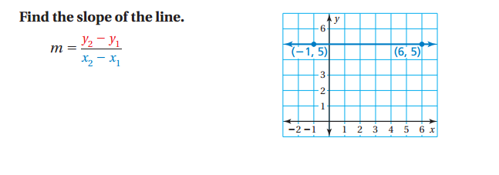
Example 3  Finding the Slope of a Vertical Line | 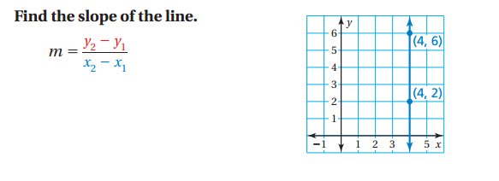
On Your Own | 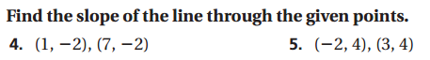
Example 4  Finding Slope from a Table | 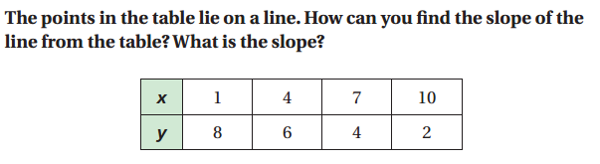
On Your Own | 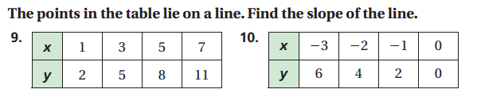
Summary | 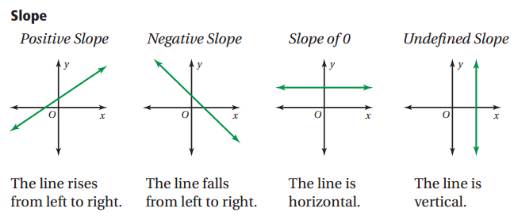
Essential Question | How can you recognize a linear equation? How can you draw its graph?  In this lesson I am learning how to graph linear equations, so I can find the solutions of the equation.
4.2 ext.  Slopes of Parallel and Perpendicular Lines | 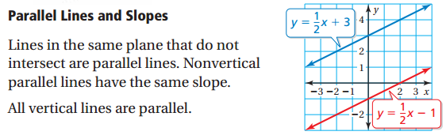
Example 1  Identifying Parallel Lines | 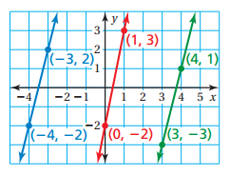
On Your Own | 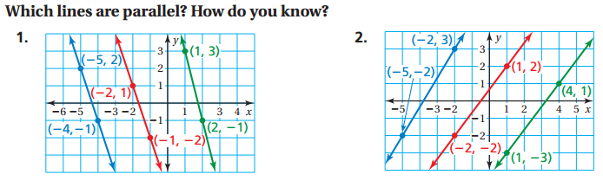  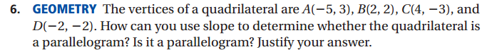
 | 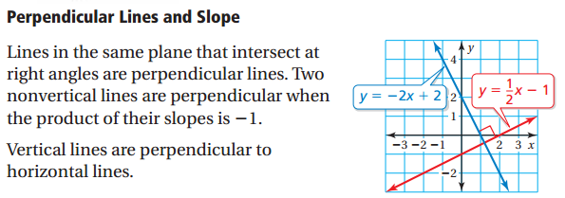
Example 2  Identifying Perpendicular Lines | 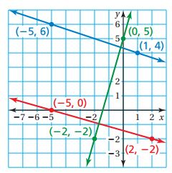
On Your Own | 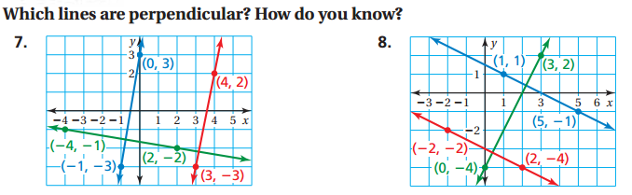  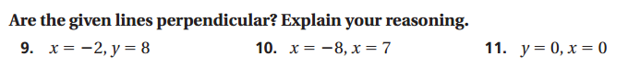  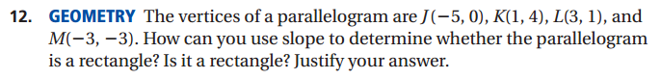
Essential Question | How can you describe the graph of the equation y=mx+b?  In this lesson I am learning how to use direct variation, so I can graph equations and interpret the slopes of the equations.
4.3  Graphing Proportional Relationships | 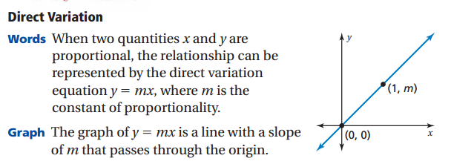
Example 1
Graphing a Proportional Relationship

Example 2  Writing and Using a Direct Variation Equation | 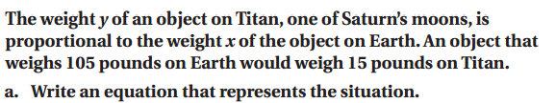
On Your Own | 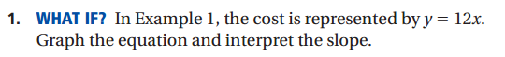  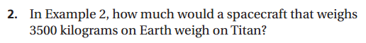
Example 3  Comparing Proportional Relationships | 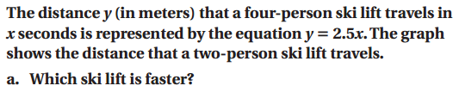  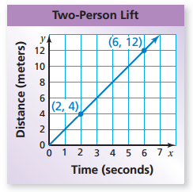  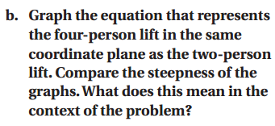
On Your Own | 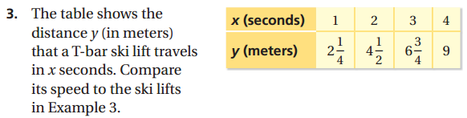
Essential Question | How can you describe the graph of the equation y=mx+b?  In this lesson I am learning how to use slope intercept form, so I can graph lines.
4.4  Graphing Linear Equations in Slope Intercept Form | 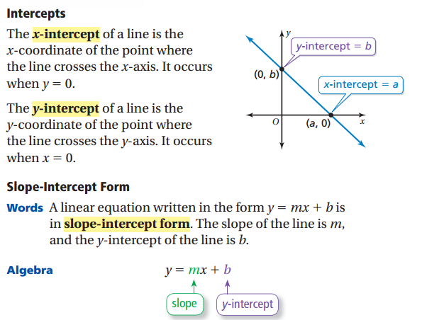
Example 1 | 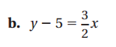
On Your Own | 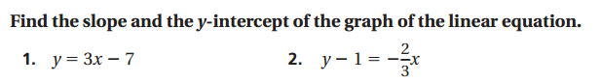
Example 2  Graphing a Linear Equation in Slope Intercept Form | 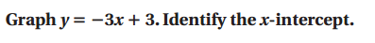
Example 3  Real Life Application | 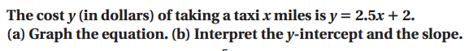
On Your Own | 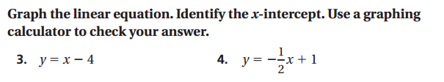  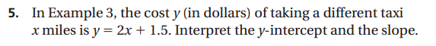

Essential Question | How can you describe the graph of the equation ax + by = c?  In this lesson I am learning how to use standard form, so I can graph lines.
4.5  Graphing Linear Equations in Standard Form | 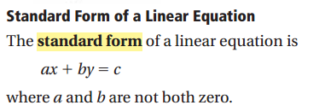
Example 1  Graphing a Linear Equation in Standard Form | 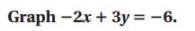
On Your Own | 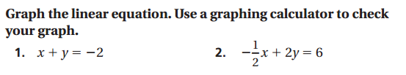
Example 2  Graphing a Linear Equation in Standard Form | 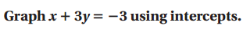
Example 3  Real Life Application | 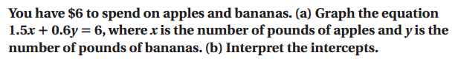  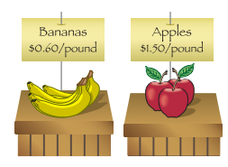
On Your Own | 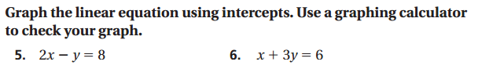  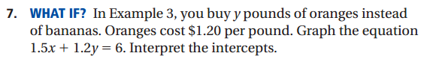
Essential Question | How can you write an equation of a line when you are given the slope and y intercept?  In this lesson I am learning how to use the slope and y intercept, so I can graph lines.
4.6  Writing Equations in Slope Intercept Form  Example 1 | 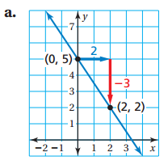  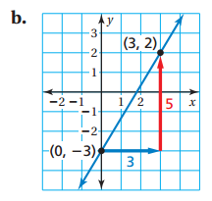
On Your Own | 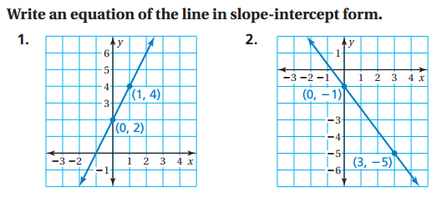
Example 2  Writing Equations | 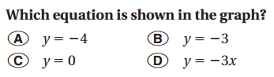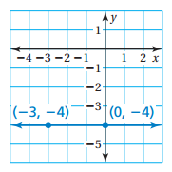
Example 3  Real Life Application | 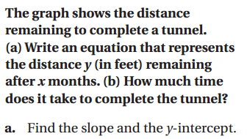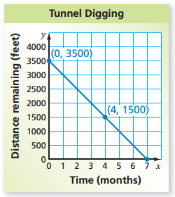
On Your Own | 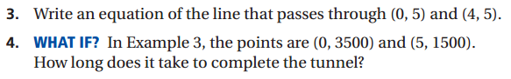
Essential Question | How can you write an equation of a line when you are given the slope and a point?  In this lesson I am learning how to use a point and a slope, so I can graph lines.
4.7  Writing Equations in Point-Slope Form | 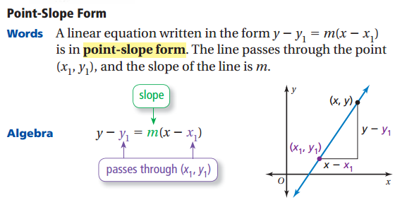
Example 1  Writing Equations using a point and a slope | 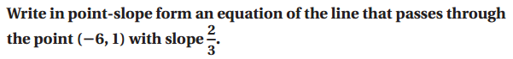
On Your Own | 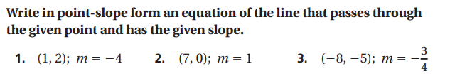
Example 2  Writing Equations using two points | 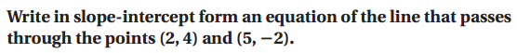
Example 3  Real Life Application | 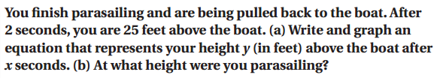
On Your Own | 