Name Date

Review

Semester Exam

Order the numbers from least to greatest.

1.  2. 

Simplify the expression.

3.  4.  5.  6. 

7.  8.  9.  10. 

11. On an exam you get two points for each question answered correctly, zero points for each question left blank, and lose one-half point for each question answered incorrectly. What is your total score on the exam if you answer 13 questions correctly, leave 7 questions blank,   
and answer 5 questions incorrectly?

Solve.

12.  13. 

14. A pencil costs $0.27 and a pen costs $0.32. You buy six pencils and   
the total cost is $4.18. How many pens did you buy?

15. A farmer builds a fence to enclose a rectangular pasture. He uses 155 feet of fence. Find the total area of the pasture if it is 45.5 feet long.

**Write the word sentence as an inequality.**

16. 3.2 less than a number *t* is at most 7.5.

17. A number *m* multiplied by  is greater than 

18. You and three friends are making a gift basket. You want to keep the cost below $12 per person. Write and solve an inequality that represents the total cost of the gift basket.

**Solve the inequality. Graph the solution.**

19.  20. 

TA: S:\mscc7wb03.01\Red Production\Red Assessment Book\Art\end-of-couse test\mscc7_ab_et_011.eps,1/21/2013 11:50:41 AM replaced: 7/31/2016 6:55:20 PMTA: S:\mscc7wb03.01\Red Production\Red Assessment Book\Art\end-of-couse test\mscc7_ab_et_011.eps,1/21/2013 11:50:41 AM replaced: 7/31/2016 6:55:20 PM

21. If you spend at least $50 (including shipping) at an online store, you   
receive a $10 gift card. You want to buy CDs that cost $12.50 each.   
If shipping costs $5, write and solve an inequality to find the number   
of CDs you must buy to receive the gift card.

22. The table shows the time in minutes *m* to download *s* songs. How long does it take to download one song?

|  |  |  |  |
| --- | --- | --- | --- |
| **Minutes** | 0.5 | 1.5 | 2.5 |
| **Songs** | 2 | 6 | 10 |

**Tell whether the ratios form a proportion.**

23.  24. 

25. Solve the proportion 

Find the slope of the line.

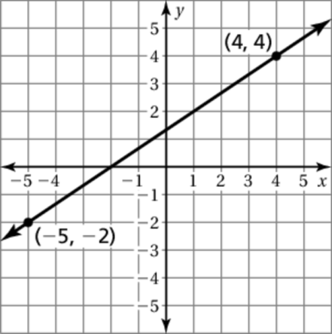 26. 27. 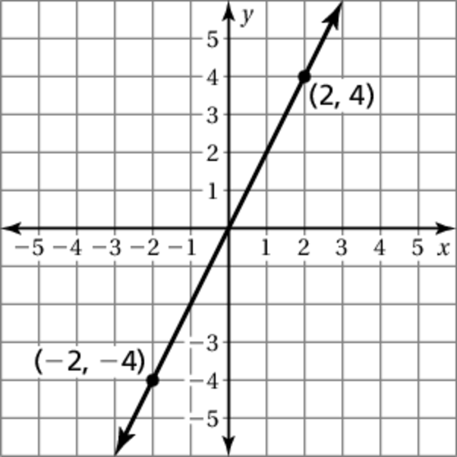

28. If 27% of a number is 11.34, what is the number?

29. A store sign reads, “Take 90% off the original price when you take   
an additional 15% off the sale price, which is 75% off the original price.” Is the store’s sign accurate? Explain.

30. You put $1205 in an account that earns 2.5% simple interest. Find   
the total amount in the account after four years.